12.2: Use of Eq. (12.1) gives

The ratio of this force to the satellite’s weight at the surface of the earth is
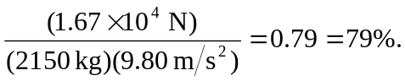
(This numerical result requires keeping one extra significant figure in the intermediate calculation.) The ratio, which is independent of the satellite mass, can be obtained directly as
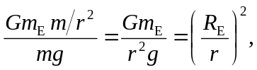
yielding the same result.

